Social Media Strategy:
Fan Acquisition

Fan Acquisition Strategies
- Social Media Advertising
  - Facebook Advertising
  - Twitter Advertising
  - LinkedIn Advertising
  - Instagram Advertising
- Roll Out Plan

Fan Acquisition Strategies

1. Social Media Advertising

1.a. Facebook Advertising
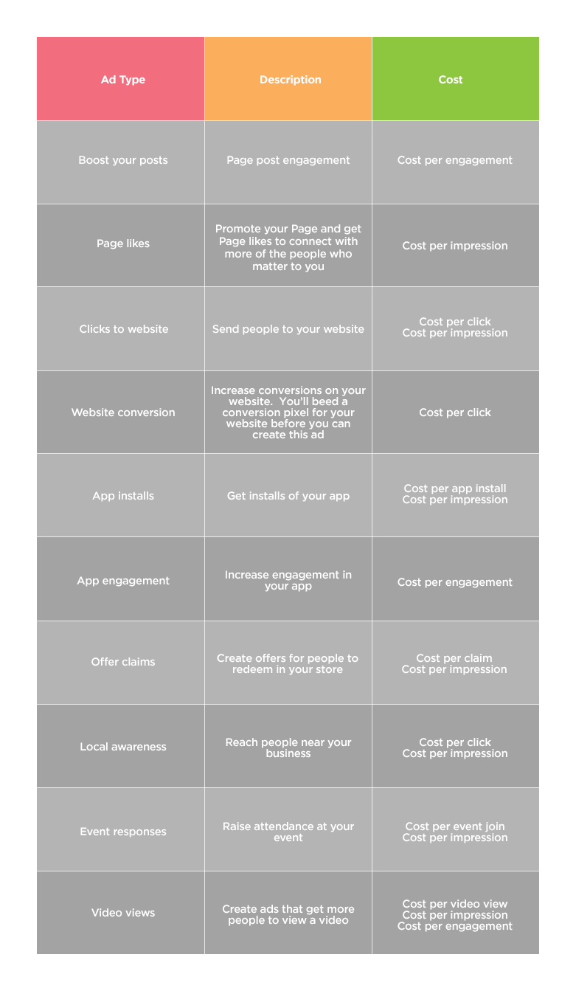

1.b. Twitter Advertising
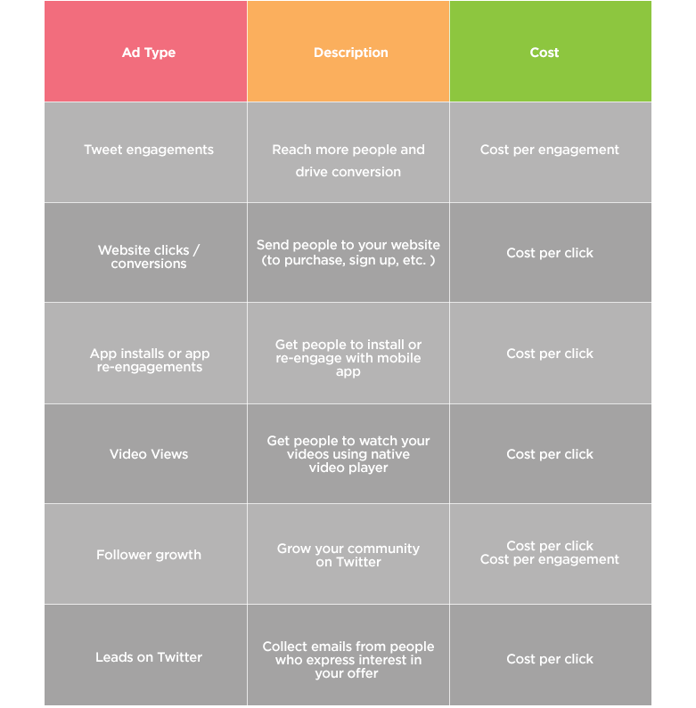

1.c. LinkedIn Advertising
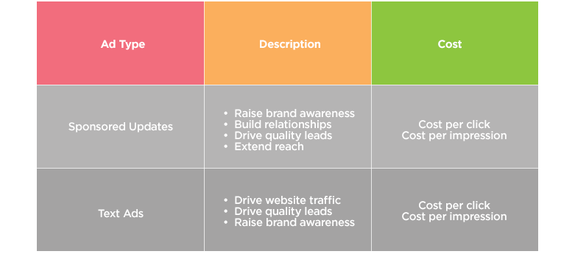

1.d. Instagram Advertising
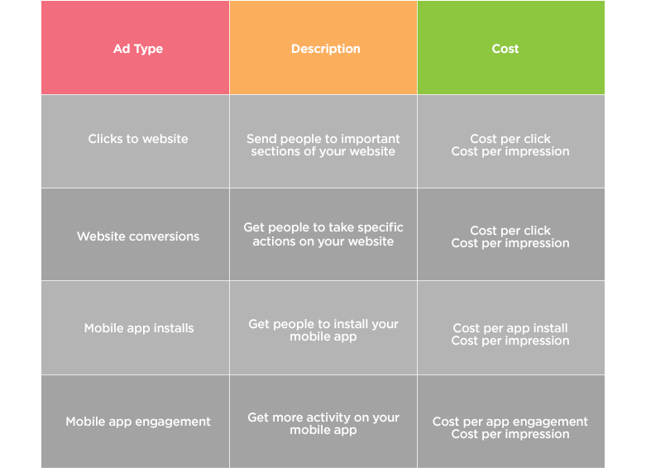

2. Roll Out Plan

Strategy | Month 1 | Month 2 | Month 3 | Month 4 | Month 5 | Month 6
eg. Facebook advertising
eg. Facebook competitions
eg. LinkedIn advertising
eg. Electronic Direct Mail (EDMs)

